OTHER WAYS OF SUPPORTING
DORSET HISTORIC CHURCHES TRUST
RIDE + STRIDE
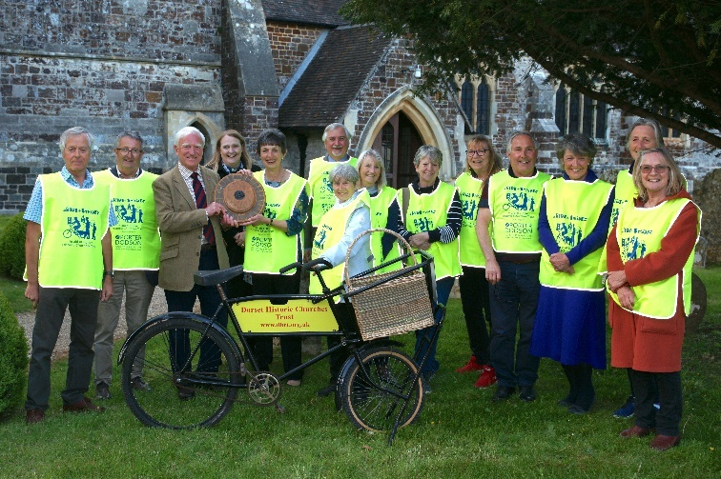

Ride + Stride is a sponsored event in which people walk, cycle or horse-ride between churches, whilst exploring our wonderful Dorset countryside and enjoying the hospitality of our church communities. Some even walk with their dog and have it sponsored, and others walk to a fund-raising coffee morning!

The money raised (over £107,000 in 2021) is used to help conserve Dorset’s churches and chapels and to help keep them active and at the heart of their communities for the use of future generations. Half of the money raised is returned directly to your nominated church and the other half goes towards funding our grants programme.

You can help by either “Riding or Striding” yourself or by encouraging or sponsoring a friend or neighbour who is taking part.

MAKE A DONATION
The needs of our churches are pressing and you may prefer to make a gift now that will be appreciated during your lifetime. By making regular annual or monthly payments you will be contributing to the preservation of an inheritance going back many centuries.

Please fill in the Banker’s order and Gift Aid Declaration.

LEAVE A BEQUEST IN YOUR WILL
A bequest is an efficient way for many people to donate to the Trust more substantially than their present circumstances permit. A bequest is not liable to Inheritance Tax. You may wish to consider three common forms of legacy:
A legacy of money. This is a gift of a specific amount. Inflation may erode its value but this can be avoided by making provision for the amount to be increased automatically in line with the prices index.
A legacy of property. It is possible to leave gifts in the form of land, shares, pictures or other valuables. The Trust would sell the asset at an appropriate time and apply the proceeds to its work.
A Residuary legacy. This is part or all or your Estate after all other legacies and obligations have been fulfilled.
If you decide to leave a legacy to help the Trust, you should seek professional legal advice. In the meantime, the Chairman or the Honorary Secretary would be pleased to take questions and to give guidance on these matters. Their contact details are on the About Us page of the Trust’s website: www.dhct.org.uk

Dorset Historic Churches Trust

Registered Charity Number: 282790 - Jun 2022


BECOME A FRIEND OF
DORSET HISTORIC CHURCHES TRUST
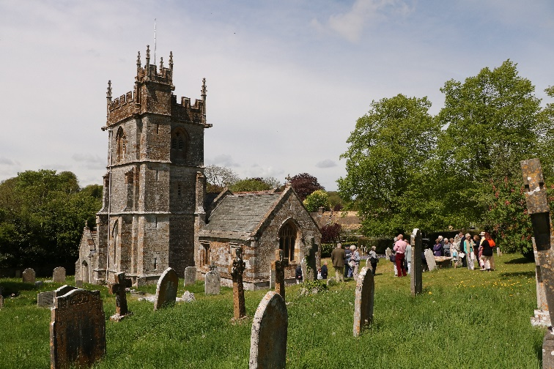
There are more than 400 historic churches and chapels in Dorset, nearly 300 of which date back to the Reformation and some even before the Norman Conquest. Since our foundation in 1960 Dorset Historic Churches Trust has provided over one million pounds through grants or loans to over 250 churches and historic buildings from all denominations of the Christian faith. Originally concerned with churches over 150 years old, in recent years we have recognised the significance of Gothic Revival, Edwardian and early 20th Century buildings.
This has greatly increased our involvement with churches and chapels across the county. We are a registered charity receiving and providing funding entirely on a voluntary basis with only about 10% administrative expenses. We get no financial support from the Church of England, Local Authorities or English Heritage.
Many of the county’s churches are of unique and significant architectural interest and are repositories of national and local history as well as being an integral part of community life. Our churches receive little financial support from government and, facing the need to comply with Listed Building regulations and escalating building costs, the tasks of maintenance and renewal are often beyond the resources of our smaller, particularly rural, parishes.
This is where the Dorset Historic Churches Trust comes in! In the past 5 years we have awarded grants averaging over £100,000 per year to needy churches.
Please visit our website: http://www.dhct.org.uk for full details of all aspects of our work.
We are inviting you to become involved in the work of the Trust by joining our Friends, who number over 300 people. Your subscription will be used to fund the care of our churches in need. You will receive the Annual Report and our Newsletters.
Additionally, you will have the opportunity to be actively involved by attending our interesting tours of Dorset’s magnificent churches. During these popular “Church Crawls” groups of Friends are taken on expert guided tours to churches in selected areas of special interest. You will also have the chance to attend other events, such as our Lecture Lunches on church heritage in the company of our knowledgeable enthusiasts.
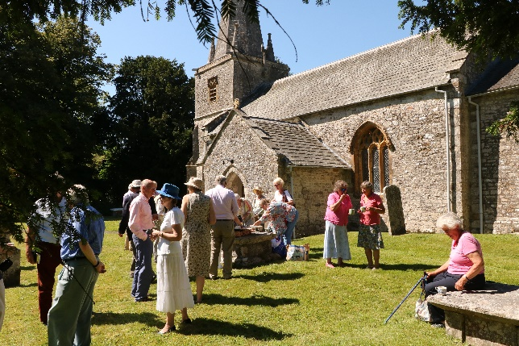
FRIENDS MEMBERSHIP
Annual individual membership is £20 and £30 for couples, but you may consider giving more.
For financial safety and to save volunteers’ time, we ask you to please set up a Standing Order with your bank to pay the annual subscription now and then on every 1st of January. You may pay by personal cheque to DHCT each year but this involves you and our volunteers in extra work.

Your Instruction to Bank
Please pay to DHCT, Lloyds Bank Dorchester
Sort code 30 – 92– 69 Account number 00412179
Reference: Friends of DHCT
The sum of £………….. now
and then on every 1st January the sum of £………….. until further notice.

From Account name………………………………………….
Account number………………………………………………….
Sort Code……………………………………………………………
Signature………………………………………………………….
Please send or take the above form to your Bank.
----------------------------------------Please complete the Friends Application form below and send it to DHCT Friends Administration whose address is at the foot of the “About Us” page of the website at http://www.dhct.org.uk

Please note that your personal information is protected in line with our data policy which can be found on our web site at http://www.dhct.org.uk

APPLICATION FOR FRIENDS MEMBERSHIP AND GIFT AID DECLARATION
Title________First Name_______________
Known as___________________________
Surname Name______________________
Address_______________________________________________________________Post Code __________________________ Email_______________________________
Tel_________________________________
Date _______________________________
Signed______________________________
Please indicate type of membership and amount
Individual £ or Couple/Joint £
GIFT AID your donation?
If you are a UK taxpayer, paying personal tax DHCT may increase the value of your donation by 25 pence in every pound. We will be most grateful if you would please complete the Gift Aid Declaration below.
I want to Gift Aid my donation and any donations that I make in the future or have made in the past 4 years to DHCT. I am a UK taxpayer and understand that if I pay less Income Tax and/or Capital Gains Tax than the amount of Gift Aid claimed on all my donations in that tax year it is my responsibility to pay any difference.
Please tick the box

Please notify the charity if you want to cancel this declaration, change your name or address, no longer pay sufficient tax on your income and/or capital gains.
If you pay Income Tax at a higher rate and want to receive the additional tax relief due to you, you must include all your Gift Aid donations on your Self-Assessment tax return or ask HM Revenue and Customs to adjust your tax code. Please send this form to the DHCT Friends Administration

